
a
Company
Logotype

Cone Beam Computed Tomography- Report



Porur Dental X-rays & CBCT

Patient Name : Mrs. Jayalakshmi | Date of Report : 21.03.2024
Age/ Gender : 46 years/ Female | Region of Interest : CBCT Full Skull
Referring doctor: Dr. Subramoniam | Indication : Implant assessment
Clinical Notes: Nil
PATIENT INFORMATION

CBCT- Full Skull provided
CBCT – IMAGE DETAILS

RADIOGRAPHIC INTERPRETATION

- Partially edentulous maxillary alveolar ridge with remaining tooth: 18.
- The maxillary alveolar ridge is present with normal trabecular pattern.

IMPLANT ASSESSMENT

 | 11 region | 12 region | 13 region | 14 region | 21 region | 22 region | 23 region | 24 region
Sub-Crestal | 6.79 | 4.72 | 6.06 | 6.62 | 5.75 | 6.76 | 5.73 | 5.83
Mid- Crestal | 7.72 | 5.97 | 7.38 | 7.86 | 7.25 | 7.54 | 5.23 | 5.32
Distance between the alveolar ridge and Floor of the Nasal cavity (in mm) | 22.1 | 17.29 | 18.4 | 17.47 | 18.63 | 15.2 | 18.34 | 18.27

 | 15 region | 16 region | 17 region | 25 region | 26 region | 27 region
Sub-Crestal (in mm) | 5.58 | 6.35 | 6.89 | 3.19 | 5.18 | 6.54
Mid- Crestal (in mm) | 7.06 | 7.43 | 8.15 | 4 | 6.35 | 7.26
Distance between the alveolar ridge and floor of the maxillary sinus (in mm) | 6.38 | 5.14 | 6.73 | 8.19 | 5.82 | 4.44

RADIOGRAPHIC IMPRESSION

- Partially edentulous maxillary arch.

Kindly correlate with clinical findings


IMAGES FOR REFERENCE

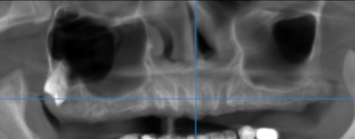

3-DIMENSIONAL VIEW

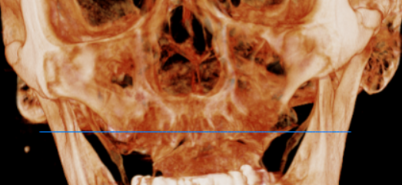

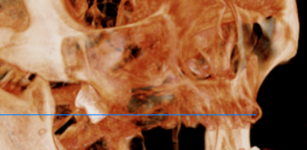
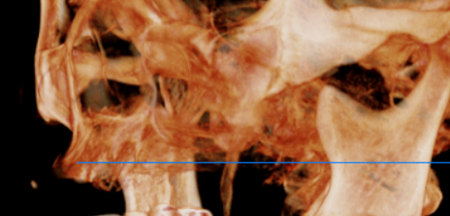

CROSS SECTIONAL VIEW

11 region | 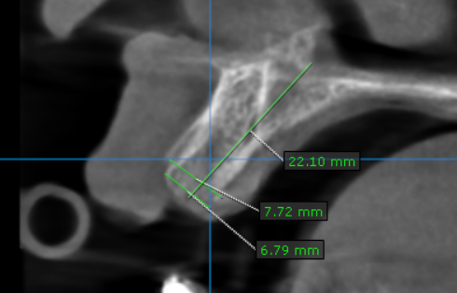
12 region | 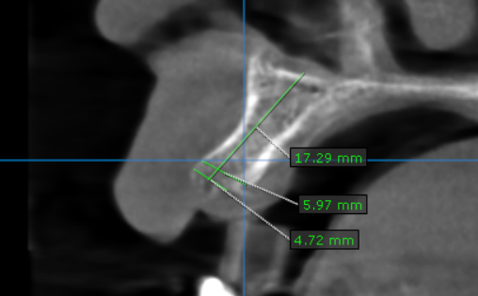
13 region | 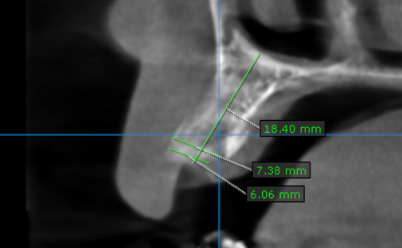
14 region | 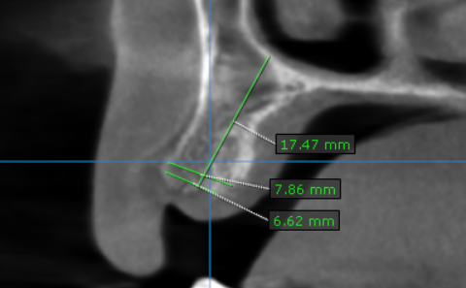
15 region | 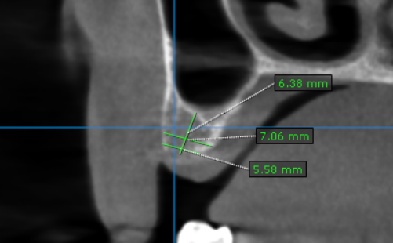
16 region | 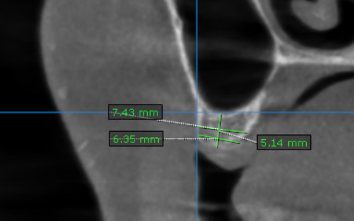
17 region | 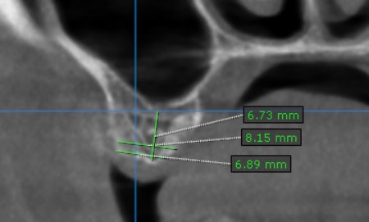
21 region | 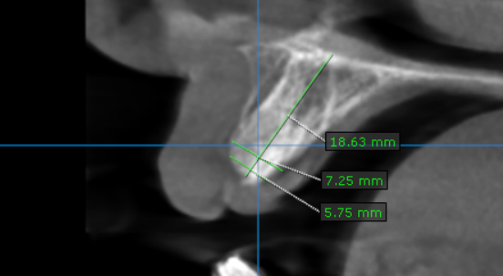
22 region | 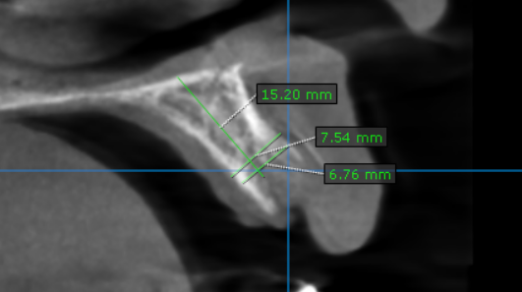
23 region | 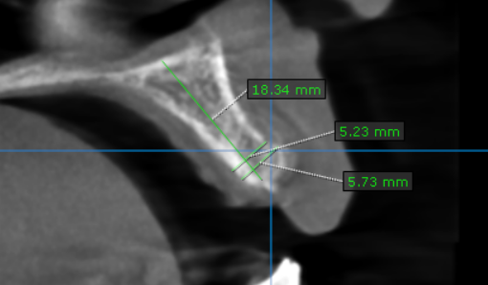
24 region | 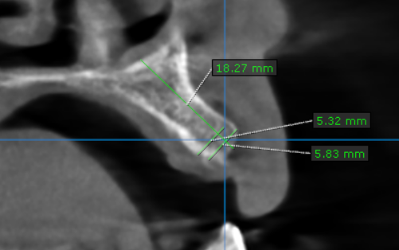
25 region | 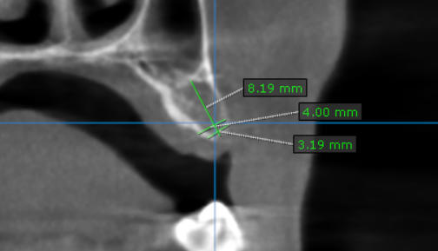
26 region | 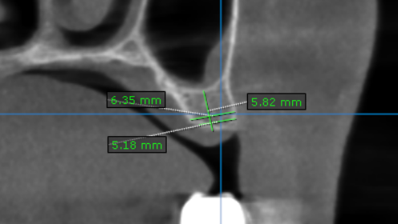
27 region | 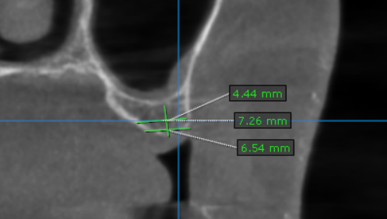

**** End of report ****

